Name …………………………………………………………………………………………….….. ADM No. ………………. Class …….

ARISE AND SHINE TRIAL 2, TERM 2 JULY 2026

GEOGRAPHY
PAPER 2

TIME: 2 ¾ HOURS

Geography
Paper 2

INSTRUCTIONS TO CANDIDATES:

- This paper consists of two sections: A and B
- Answer all the questions in section A
- Answer question 6 and any two questions from section B
- All answers must be written in the answer booklet provided

SECTION A (25 marks)
Answer all the questions in this section.
1. a) Name two provinces in Canada where wheat is grown in large scale. (2 mks)
b) List three social factors that influence agriculture. (3mks)

2. a) Name two horticultural crops grown in Kenya. (2 mks)
b) State three reasons why horticulture is more developed in the Netherlands than in Kenya. (3 mks)

3. a) State two reasons why marine fisheries in Kenya are underdeveloped. (2mks)
b) State three ways through which fish farming contributes to the economy of Kenya. ( 3 mks)
(

4. The diagram below show the occurrence of petroleum in the earth’s crust.
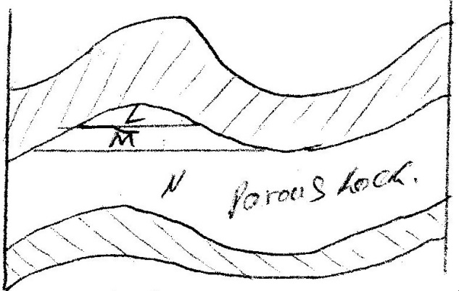
Use it to answer questions (a)

a) Name the substances in the areas labeled L. M and N (3mks)
b) Name two conditions that are necessary for the formation of petroleum. (2 mks)

5. a) Apart from desertification, name two other environmental hazards experienced in Kenya. (2 mks)
b) State three ways of controlling land pollution in Kenya. (3 mks)

SECTION B
Answer question 6 and any other two questions from this section.
6. The table below shows some of Kenya’s imports and exports in 1987. Use it to answer question (a) and (b).
Imports in Tonnes |  | Exports in Tonnes
Item | Weight | Item | Weight
Sugar  Iron & Steel  Fertilizer  Coal  Wheat | 99,000  300,000  84,000  105,000  125,000 | Coffee  Tea  Maize  Soda ash  cement | 316,000  159,000  259,000  150,000  225,000
Total | 713,000 |  | 1,109,000

a) i) Using a radius of 4cm, draw a piechart to represent the data of imports shown by
the table above. (8 mks)
ii) State three advantages of using pie charts to represent statistical data. (3 mks)

b) Explain why Kenya imports sugar and wheat yet she is a producer of the same commodities. (6 mks)
c) Explain four factors that influence importation and exportation of goods into and out of Kenya. (8 mks)

7. a) i) What is forestry? (2mks)
ii) Explain three factors that favour the growth of natural forests on the slopes of Mt.Kenya. (6mks)
iii) State five factors that have led to the reduction of the area under forest on the slopes of Mt Kenya. (5mks)
b) Explain four measures that the government of Kenya is taking to conserve forests in the country. (8mks)

c) Give the differences in the exploitation of softwood forests in Kenya and Canada under the following sub-headings;
i) Period of harvesting; (2mks)
ii) Transportation (2mks)

8. a) Name four sources of electric power other than water. (4 mks)
b) List five factors that favour location of hydroelectric power plant. (5 mks)
c) Explain five ways in which Kenya has benefited from the development of a seven forks hydroelectric power scheme. (10 mks
d) Explain three problems that Kenya face as a result of over dependence on petroleum. (6 mks)

9. a) State three physical conditions necessary for growing of sugarcane. (3 mks)
b) Describe commercial production of sugarcane from:
i) Land preparation to harvesting (6 mks)
ii) Processing to the marketing of sugar (8 mks)
c) Geography students from Siwot secondary went for a field study at Mumias sugar factory.
i) Identify two methods they used to collect data (2 mks)
ii) Explain three problems they identified facing sugar-cane farmers in Kenya. (6 mks)

10. a) The map below shows the trans-African highway from Mombasa to Lagos.
Use it to answer questions below:
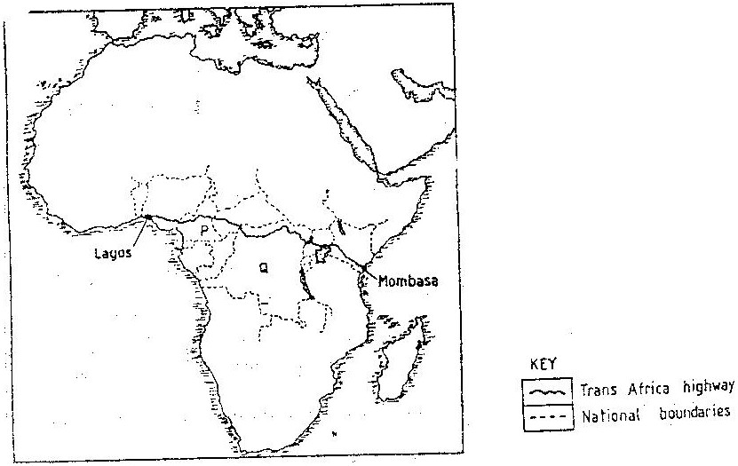

i) Name the countries marked P and Q (2mks)
ii) State three reasons why it is difficult to transport goods from Mombasa to Lagos along the highway. (3mks)
b) Name three products transported by pipeline. (3 mks)
c) State three reasons why there are few railway lines among African countries. (3mks)
d) Explain three ways in which Kenya has benefited from her international airports. (6 mks)
e) Describe four problems facing transport and communication in Africa. (8 mks)

